

**Test Case: AWS EKS { WordPress WorkLoad and Prometheus Test Case}**

* Amazon EKS (Elastic Container Service for Kubernetes)

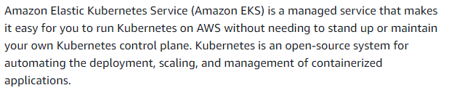

Read more from: <https://aws.amazon.com/eks/>

* **Perquisites:-**

Below components are required to be installed in your laptop or desktop before you go ahead in this journey. (In my case I’m using Windows 10/ Laptop to complete this test case.)

* AWS CLI :-

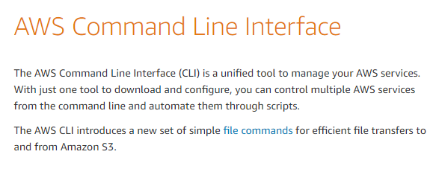

To know more and how to install go through this Amazon official link: - <https://aws.amazon.com/cli/>

* **Kubectl :-**

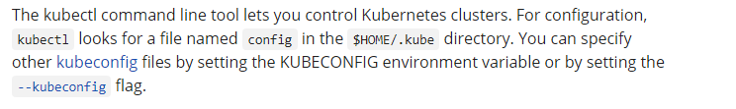

To know more and how to install go through this Amazon official link: - <https://docs.aws.amazon.com/eks/latest/userguide/install-kubectl.html>

* **eksctl** 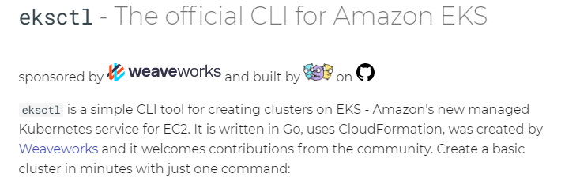

To know more and how to install go through this link: <https://eksctl.io/>

I’ve kept these required tools in a path and set the environment variable path for the easy access: (Keeping in one path all the executable it easy to do the troubleshooting)

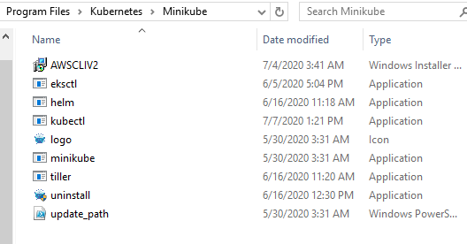

**Steps to create EKS Cluster:-**

1. eksctl create luster –f cluster.yml

(yml code attached in the given github link) above command need to be run from the path where the yml file kept.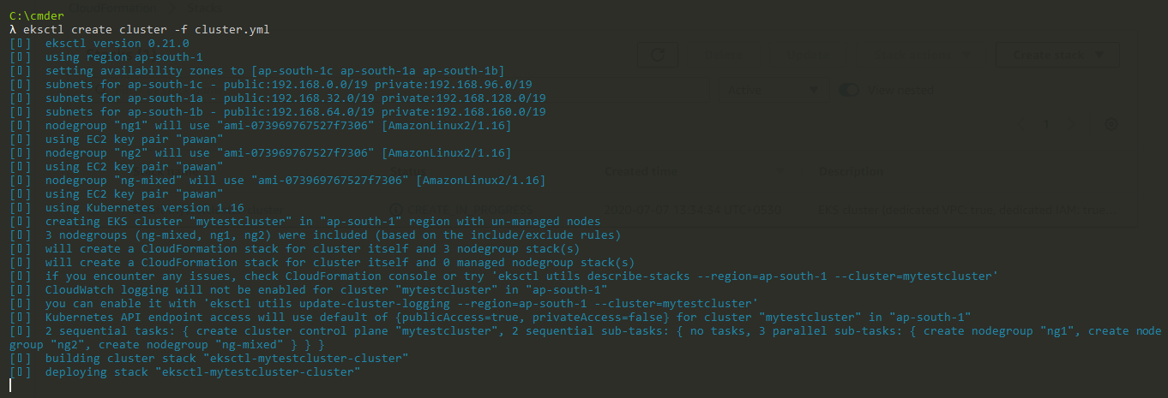

Same can be cross-checked from AWS Console :-

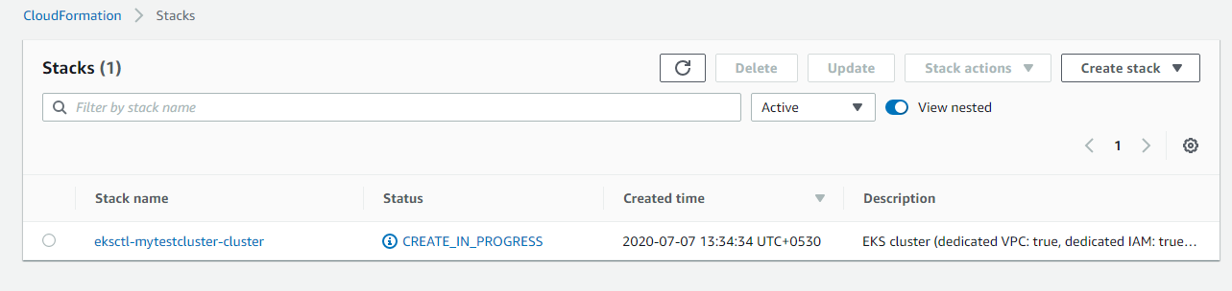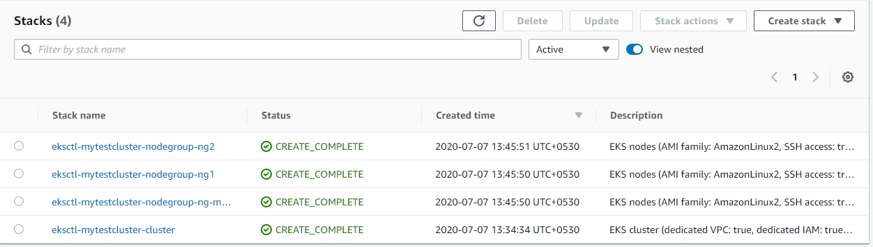

Successful cluster creation:-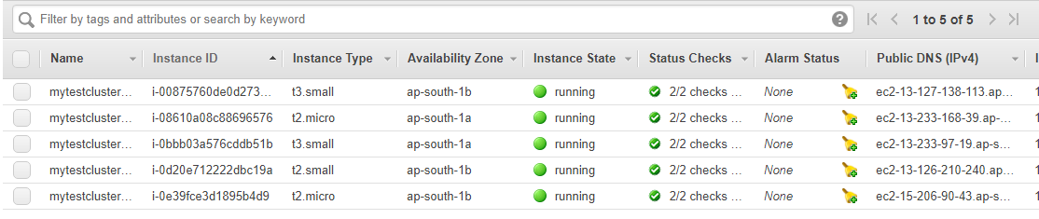

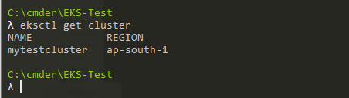

Node can be accessed using publick IP:-

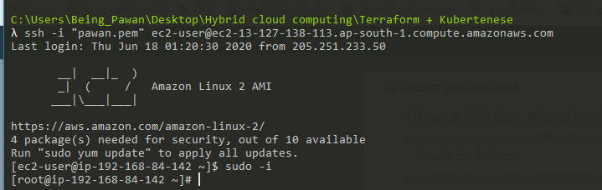



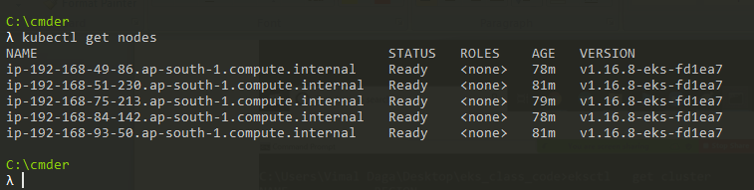

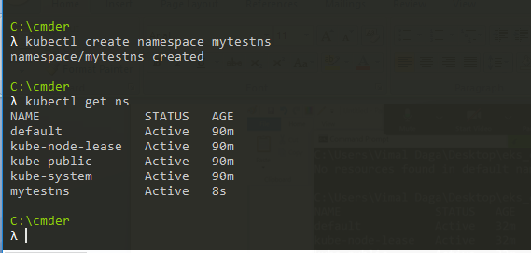

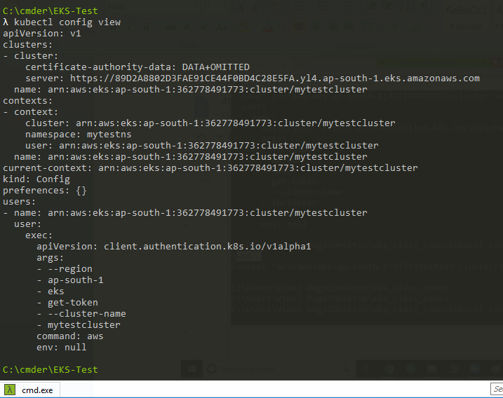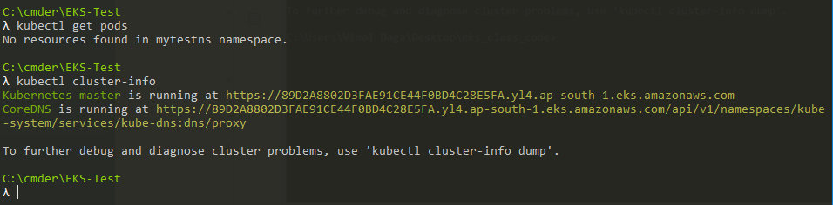

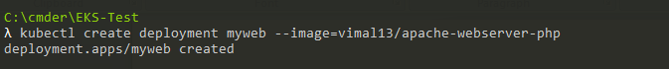

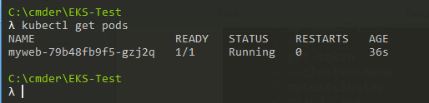

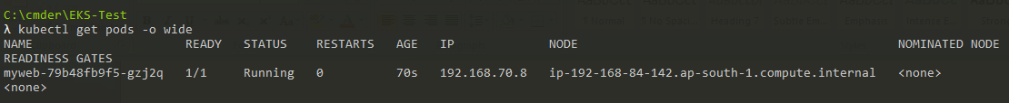

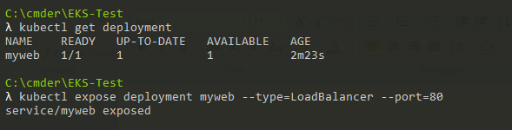



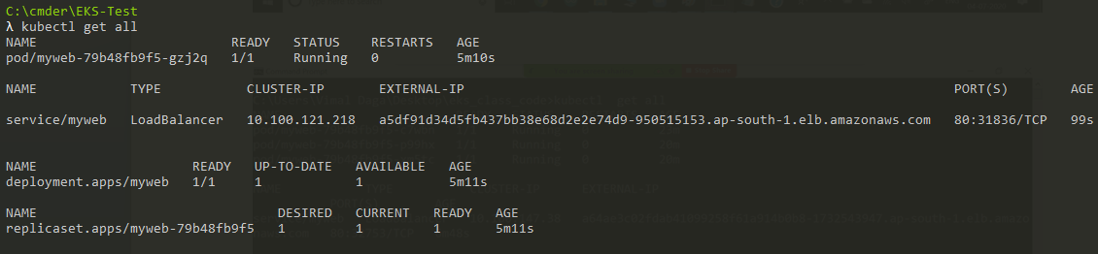

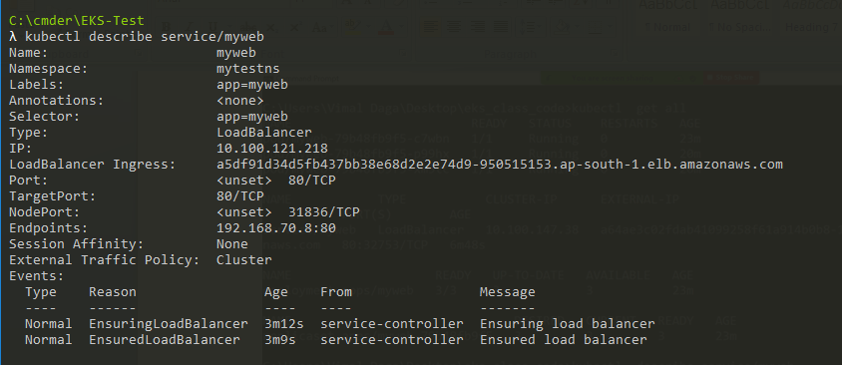

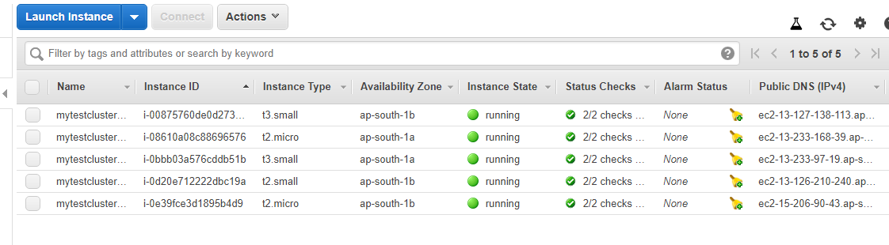

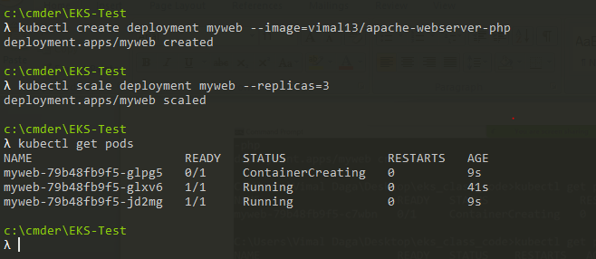

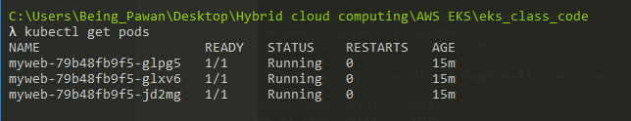

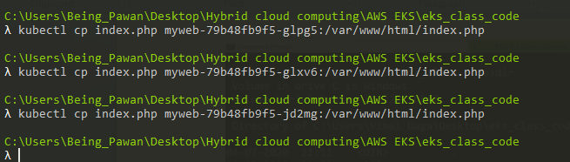

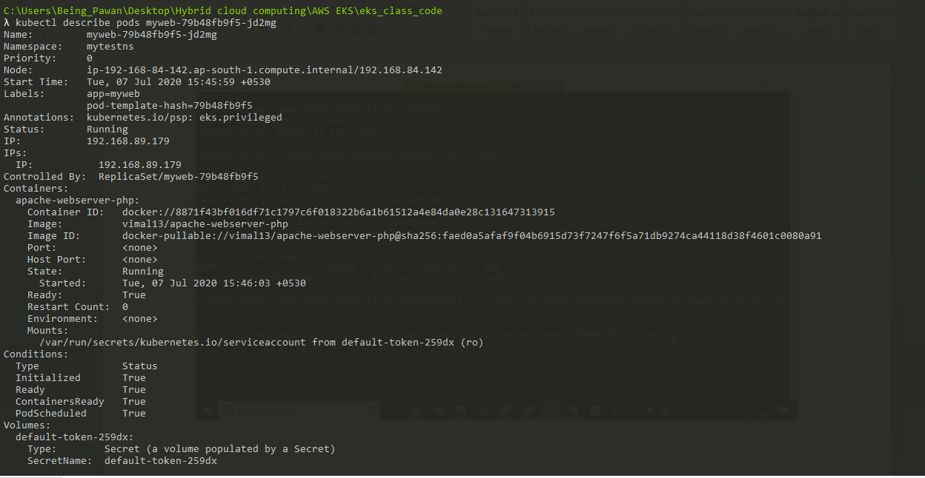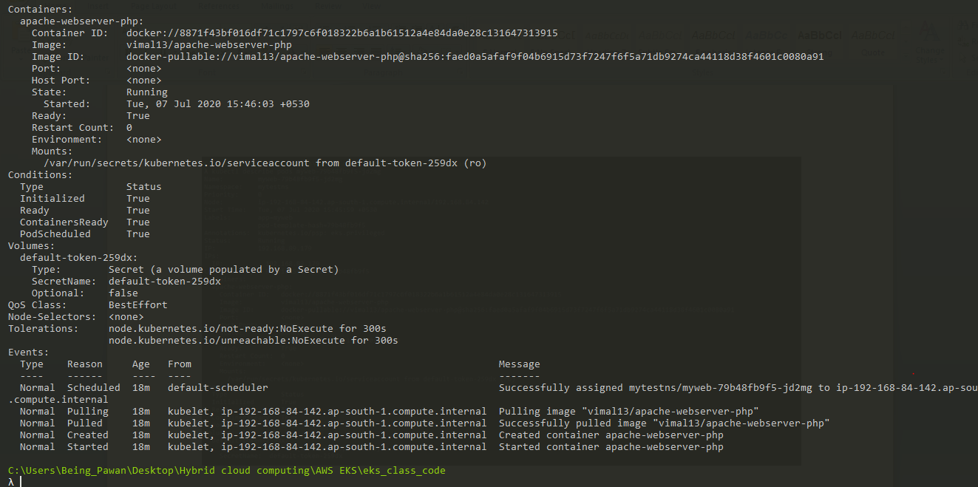

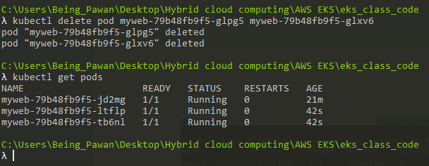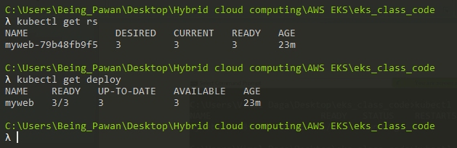

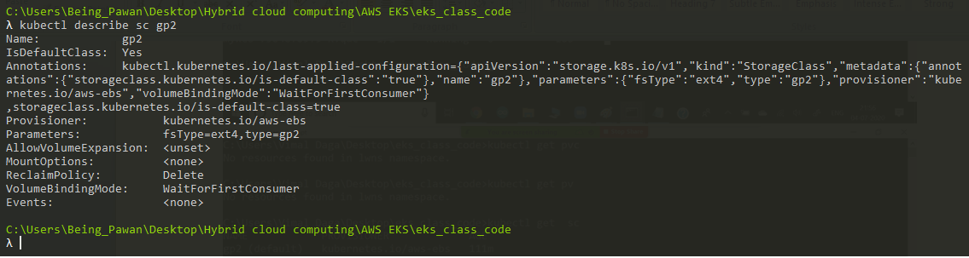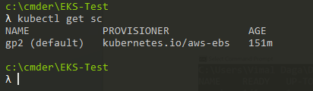

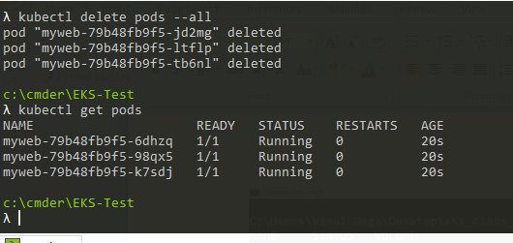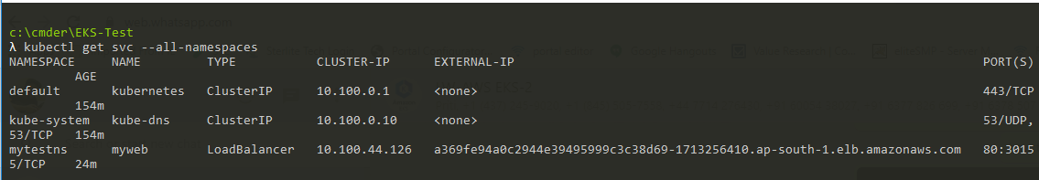

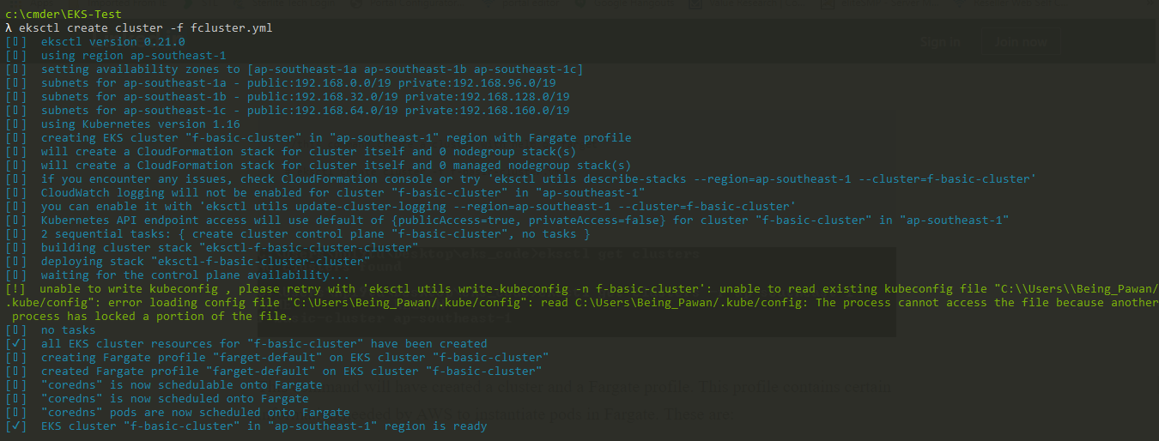

For using Fargate update the kubeconfig view...

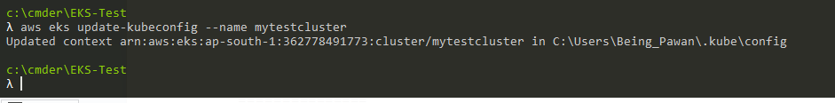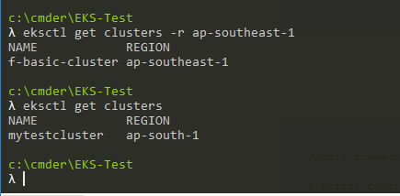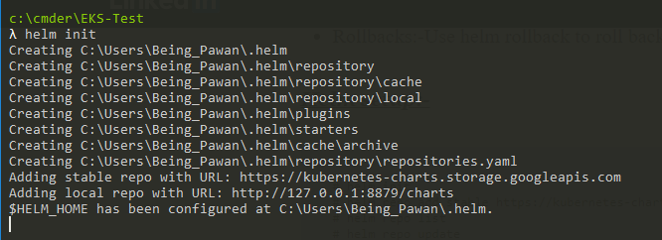

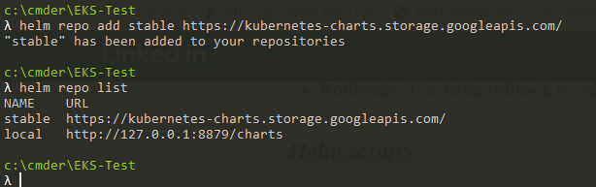

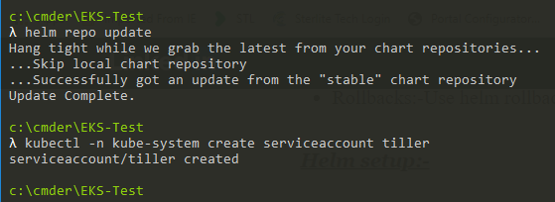

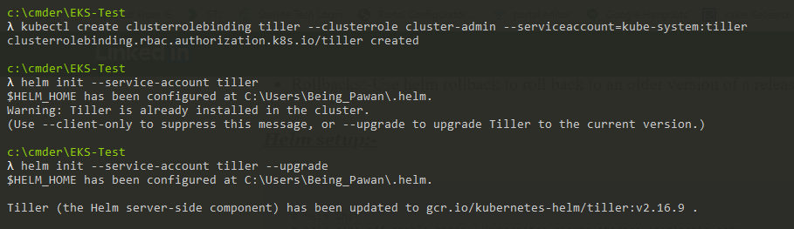

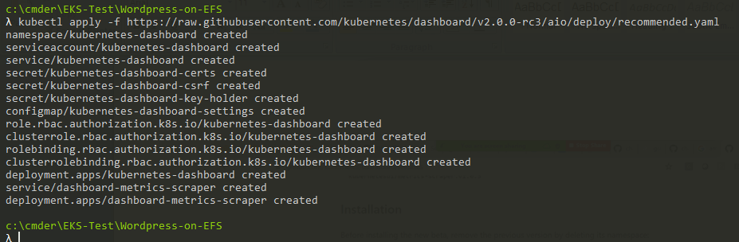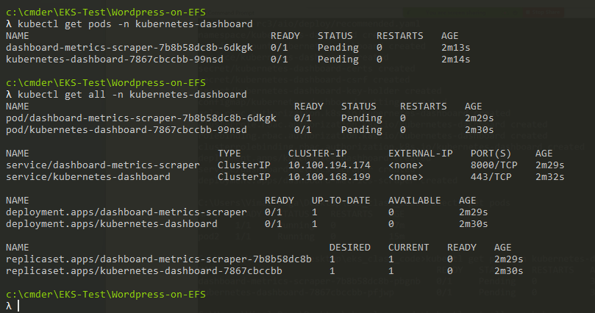<https://www.eksworkshop.com/intermediate/240_monitoring/deploy-prometheus/>

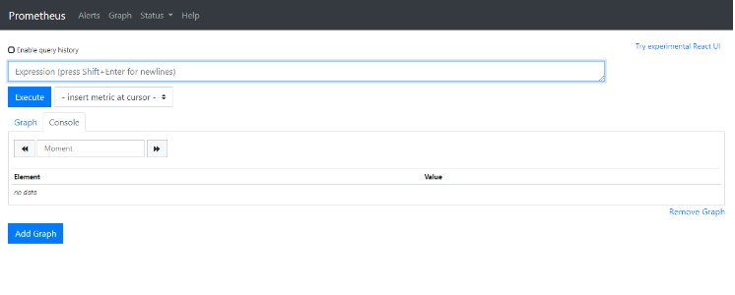

Creation of Farget Cluster:-

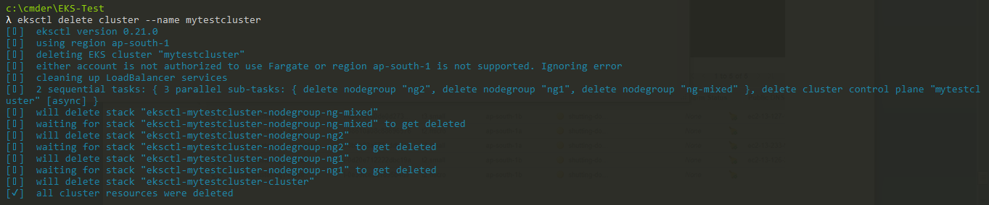

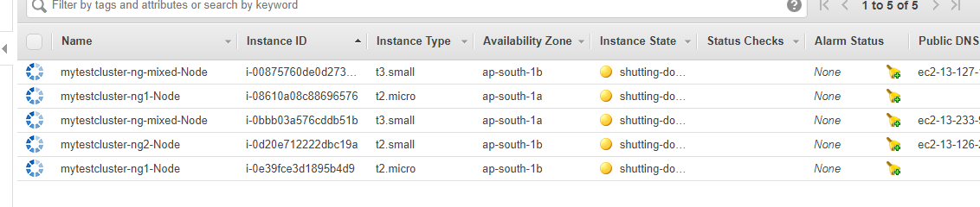

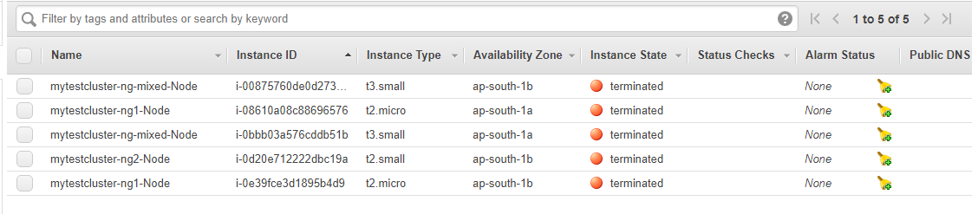

Thanks for going through this article !!

**Caution: Do watch your AWS bills carefully.**